**Week 4 – LAB 3**

1. **First question:**

Write a Java program to get a number from the user and print whether it is positive or negative and if it is odd or even.

1. **Second question**

Take three numbers from the user and print the greatest number and the smaller number.

1. **Third question:**

Write a Java program that reads a floating-point number and prints "zero" if the number is zero. Otherwise, print "positive" or "negative". Add "small" if the absolute value of the number is less than 1, or "large" if it exceeds 1,000,000.

1. **Forth question:**

Write a Java program to solve quadratic equation: **ax2 + bx + c =0**. Where a, b and c are real numbers and a != 0

The term **b2-4ac**is known as the discriminant of a quadratic equation. It tells the nature of the roots.

1. If the discriminant is greater than 0, the roots are real and different.

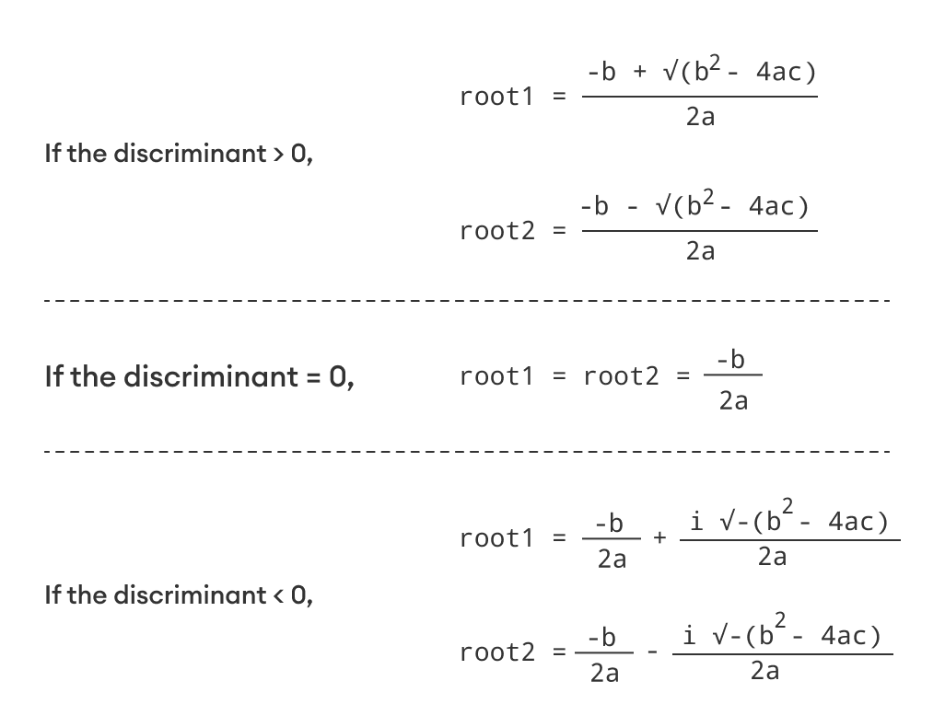

1. If the discriminant is equal to 0, the roots are real and equal.



1. If the discriminant is less than 0, the equation has no real root.
2. **Fifth question:**

Write a Java program that reads two floating-point numbers and tests whether they are the same up to three decimal places.